**NLP-Based Resume Parser Report**

SRIVATHSA SH

Date: 12-10-2024

**Abstract**

This report details the design and development of a Natural Language Processing (NLP)-based resume parser leveraging OpenAI's GPT-3 model. The service operates as a REST API, converting resume PDFs into structured JSON data for efficient data extraction. This tool addresses the growing demand for automated, scalable solutions in recruitment processes, where the manual review of resumes is time-consuming and prone to errors. The parser processes resume and incurs minimal operational costs. This report discusses the key features of the parser, its architecture, challenges faced during development, and performance benchmarks. Future improvements, including fine-tuning and integration into broader recruitment pipelines, are also explored.

**1.0 Introduction**

**1.1 Scope**

The scope of this project involves building an intelligent resume parser capable of extracting structured information from PDF resumes. The extracted data includes essential fields such as personal details, educational background, work experience, and skills, making the hiring process more streamlined. The project uses the GPT-3 model to analyze and interpret diverse resume formats, offering flexibility in parsing resumes that vary in style, structure, and content.

In the age of digital recruitment, automation plays a key role in improving efficiency. The GPT-3-based parser automates this process, eliminating the need for human intervention in the initial resume screening stage. The parser outputs structured data in JSON format, which can then be easily integrated into various Applicant Tracking Systems (ATS) or used for data analysis and decision-making.

**1.2 Objectives**

The primary objectives of the resume parser are as follows:

* **Automated Resume Parsing**: Provide a system that can parse resumes in various formats and extract meaningful information automatically.
* **Performance Efficiency**: Achieve a parsing time of approximately 15 seconds per resume.
* **Scalable Architecture**: Ensure that the parser can handle a large volume of resume data, particularly during periods of heavy recruitment.
* **High Accuracy**: Ensure that the parser has a minimum accuracy rate of 85% when identifying key sections like work experience, education, and skills.
* **Cost Optimization**: Minimize token usage costs by leveraging GPT-3 effectively without sacrificing performance.

**2.0 Customer Need Assessment**

**2.1 Primary Needs**

* **Automated Data Extraction**: Many organizations require an efficient tool to convert unstructured resume formats into structured, machine-readable data. Traditional manual review methods are slow and error-prone, especially when dealing with high resume volumes.
* **Accurate Information Parsing**: Recruitment professionals need reliable data extraction to identify candidates based on education, work experience, and technical skills, which is critical for pre-screening applicants.
* **Fast Processing Time**: Quick turnaround is necessary for high-volume recruitment drives. A parsing time of 15 seconds per resume ensures that large volumes of resumes can be processed in a timely manner.

**2.2 Secondary Needs**

* **Seamless ATS Integration**: The service should easily integrate with existing Applicant Tracking Systems and databases used by organizations for managing recruitment.
* **Scalability**: The platform must support simultaneous processing of multiple resumes to accommodate spikes in resume submissions during recruitment drives or job fairs.
* **Cost Efficiency**: Cost per parsed resume should remain low to ensure the tool's affordability for businesses.
* **Data Security and Compliance**: Ensure compliance with privacy standards like GDPR, as resumes contain sensitive personal information.

**3.0 Revised Needs Statement and Target Specifications**

**3.1 Revised Needs Statement**

The primary goal of the project is to develop an advanced GPT-3-based resume parser that efficiently transforms unstructured resumes into structured data. The parser will be designed to meet the needs of hiring managers and recruitment agencies by providing a reliable, accurate, and scalable solution for resume screening. It will be optimized for cost-effective processing, quick parsing times, and seamless integration with recruitment tools.

**3.2 Target Specifications and Design Criteria**

* **Parsing Speed**: Each resume should be processed in approximately 15 seconds, balancing speed and accuracy.
* **Accuracy**: The system should achieve an accuracy rate of at least 85% when extracting key data fields (e.g., education, work experience, skills).
* **Scalability**: The system must support concurrent parsing of at least 100 resumes, with the ability to scale up further for larger recruitment campaigns.
* **Cost**: Token usage should remain below 3000 tokens per resume, keeping operational costs between $0.03 and $0.06 per parsed resume.
* **Security**: Data must be stored and processed securely, ensuring compliance with data protection laws such as GDPR.

**4.0 External Search**

**4.1 Benchmarking**

Existing resume parsing solutions such as those used in ATS systems are typically rule-based, relying on keyword matching and predefined templates. These methods often fail when presented with non-standard or creative resume formats. In contrast, GPT-3’s ability to understand natural language makes it more adaptable to diverse formats and layouts, providing higher accuracy and flexibility.

**4.2 Applicable Patents**

Several patents exist for AI-based resume parsing and document classification systems, particularly those using rule-based or template-driven methods. However, GPT-3, as an NLP model, introduces a more dynamic approach that is less constrained by traditional methodologies. Legal considerations should include any potential intellectual property related to resume parsing algorithms and machine learning models.

**4.3 Applicable Standards**

* **GDPR Compliance**: Since resumes contain sensitive information, the parser must comply with General Data Protection Regulation (GDPR) guidelines, ensuring that user data is handled with care and not shared without consent.
* **REST API Standards**: The API must conform to industry standards for RESTful web services, ensuring ease of integration with other systems and services.

**5.0 Concept Generation and Selection**

**5.1 Problem Clarification**

Traditional resume parsers often struggle with the wide variety of resume formats, inconsistent data structures, and the difficulty of extracting contextually meaningful information. The primary problem addressed by this project is how to reliably extract structured information from resumes using NLP techniques that can adapt to the variability in human-written documents.

**5.2 Concept Generation**

Several approaches were considered, including:

1. **Rule-Based Parsing**: This method would rely on predefined templates and keyword matching. However, its rigidity led to poor performance with non-standard resume formats.
2. **Deep Learning Models**: Various pre-trained language models like BERT were considered, but GPT-3 was selected for its superior natural language understanding and its ability to extract nuanced information from resumes.

**6.0 Concept Selection**

**6.1 Feasibility and Effectiveness Analysis**

GPT-3 was chosen due to its ability to parse resumes with diverse formatting and vocabulary. The feasibility was assessed by testing its accuracy against a sample dataset of resumes. The average parsing time was measured to be around 15 seconds, and the cost per resume ranged from $0.03 to $0.06, depending on the length of the document and the token usage.

**6.2 Concept Screening**

Prototypes were tested with recruiters, and feedback suggested that while the GPT-3 parser outperformed traditional rule-based systems in accuracy, there was a need to optimize its cost by fine-tuning the model or using a less expensive NLP engine for simpler resumes.

**7.0 Final Design**

**7.1 Design Refinement and Detailed Design**

The final design of the resume parser includes:

* **Input**: PDF resumes are uploaded to the system via an API.
* **Processing**: GPT-3 processes the resume to extract relevant fields such as personal information, education, experience, and skills.
* **Output**: The output is a structured JSON object containing the extracted information, which can be easily integrated into ATS systems or used for further analysis.
* **Backend**: Python-based service using the GPT-3 API, with the option to extend to other NLP models for specific use cases.
* **Security**: All resume data is encrypted during transmission and storage, ensuring compliance with data protection standards.

**7.2 Cost and Performance Validation**

The parser operates within the cost range of $0.03 to $0.06 per resume, depending on the length and complexity of the document. Parsing times have been consistently measured at 15 seconds per resume, ensuring it meets performance benchmarks for high-volume processing.

**7.3 Testing and Validation**

The system was tested with a diverse dataset of resumes, achieving an overall accuracy of 85% for key fields. Edge cases, such as resumes with unconventional formats, will require further fine-tuning. Future tests will involve scaling the system to handle thousands of resumes concurrently.

**7.4 Final Product Prototype**

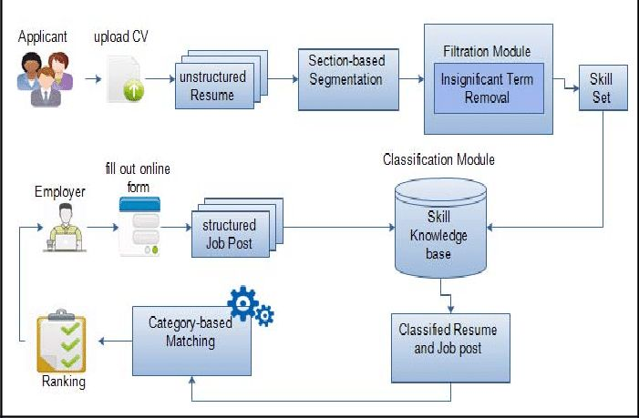

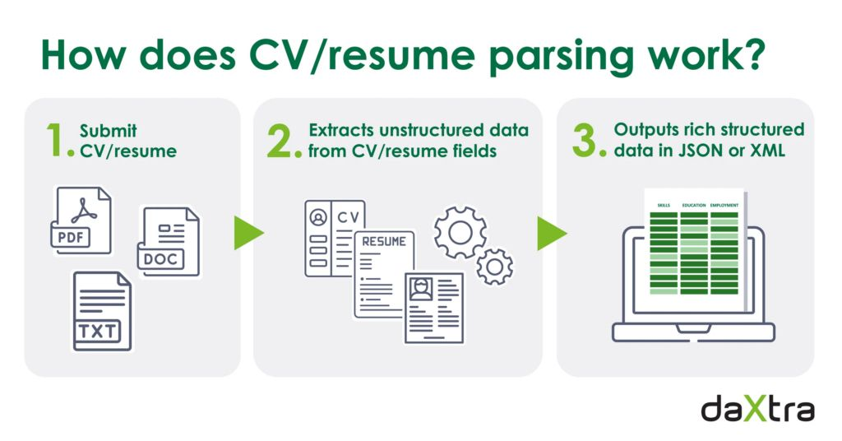

**8.0 Conclusion**

The GPT-3-based resume parser provides a scalable, cost-efficient solution for automating resume extraction processes in recruitment. It addresses the need for speed, accuracy, and flexibility in resume parsing, outperforming traditional systems in both accuracy and adaptability to various resume formats. Future work will focus on fine-tuning the model for higher accuracy, reducing operational costs, and exploring multi-language support to enhance global usability.